
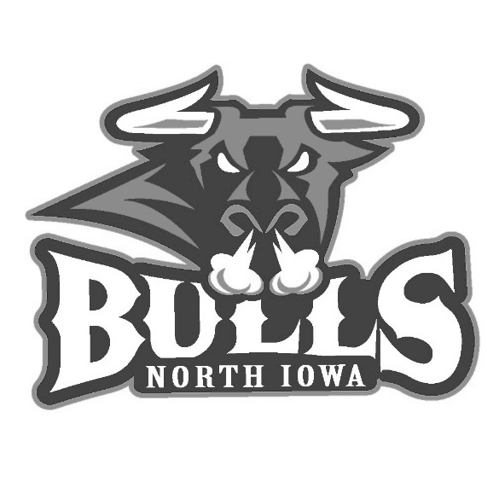

Fri. Oct 28th
Puck Drop 7:30pm
FRIGHT NIGHT AT THE BARN
Costume Contest
(Under 16 & Over 16 categories)
Jack-O-Lantern Contest
(Under 16 & Over 16 categories)
Favorite Fall Treats Contest
(Must contain Apples, Pumpkin, Cinnamon or Carmel)
NAME________________________ Age _________________
Phone #______________________
CONTEST______________________ ____________________
Favorite Fall Treats & Jack-O-Lanterns must be to arena by 6:00
Entries for Costume Contest must check in for Photo & Judging by 7:00
ALL WINNERS announced during 1st Intermission
1st, 2nd & 3rd place winners in all categories
Download and EMAIL: kcorsello@northiowabulls.com

